Task 22

Q1

Open the form <https://phptravels.com/demo/>.

Fill the form details .

Operations for form results.

Verification for form submit.

Using Take Screenshot to take screenshot.

Script:

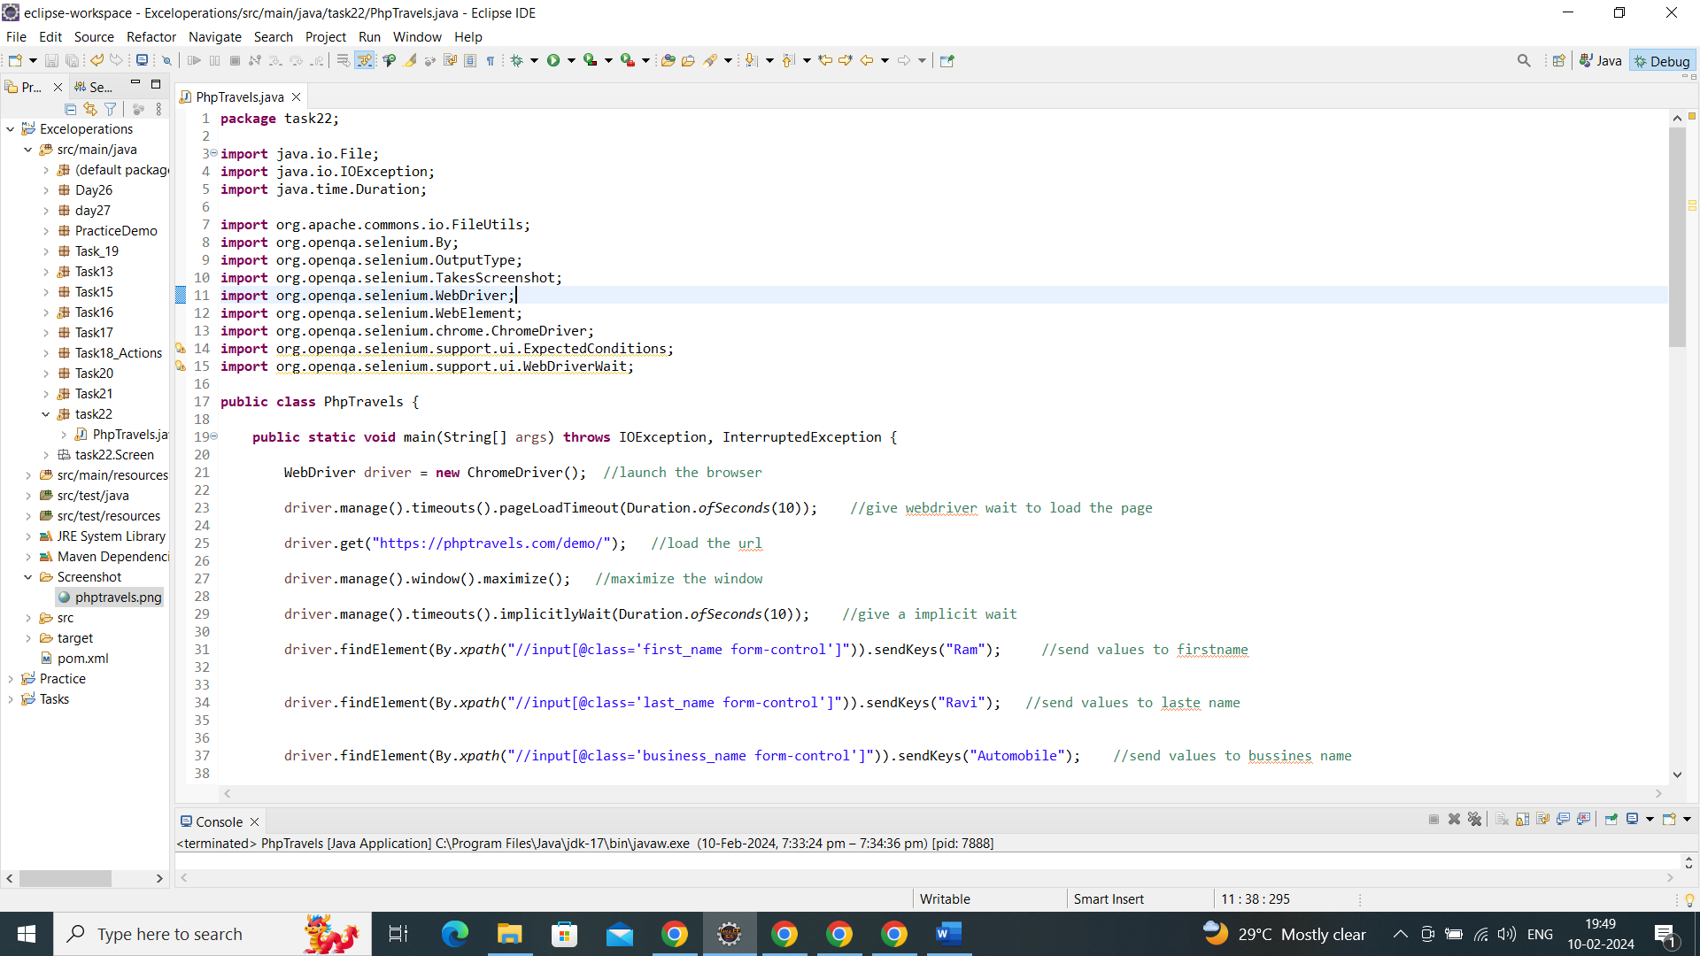

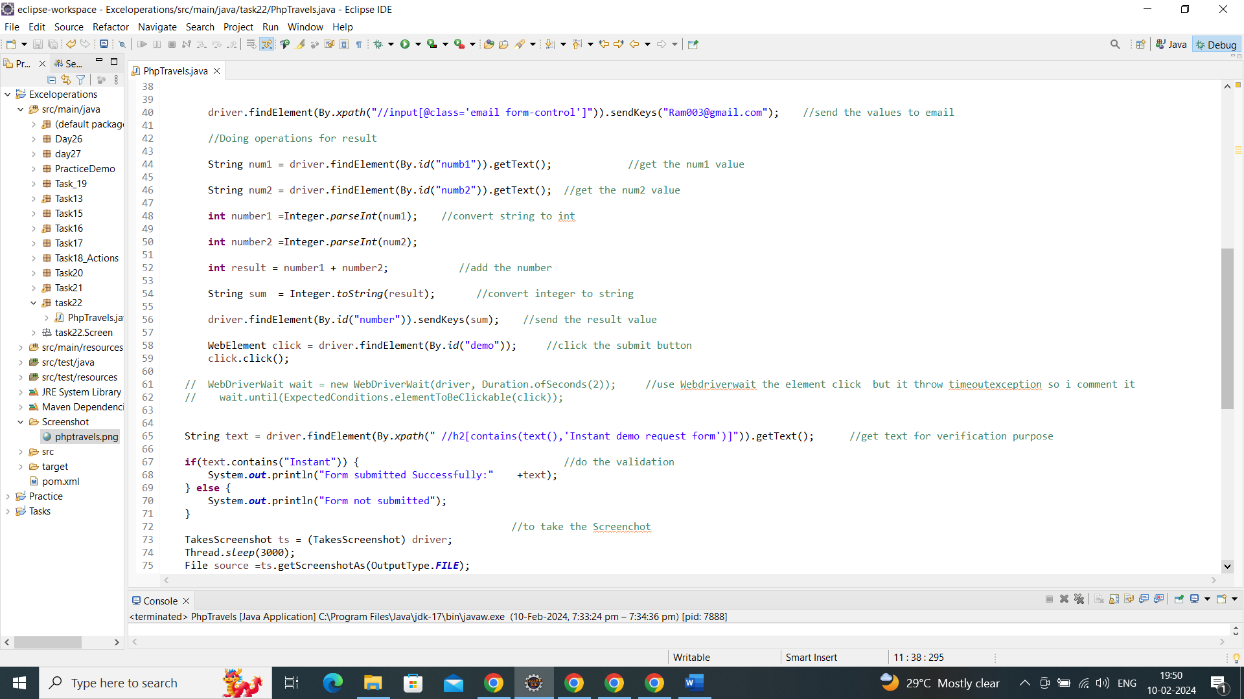

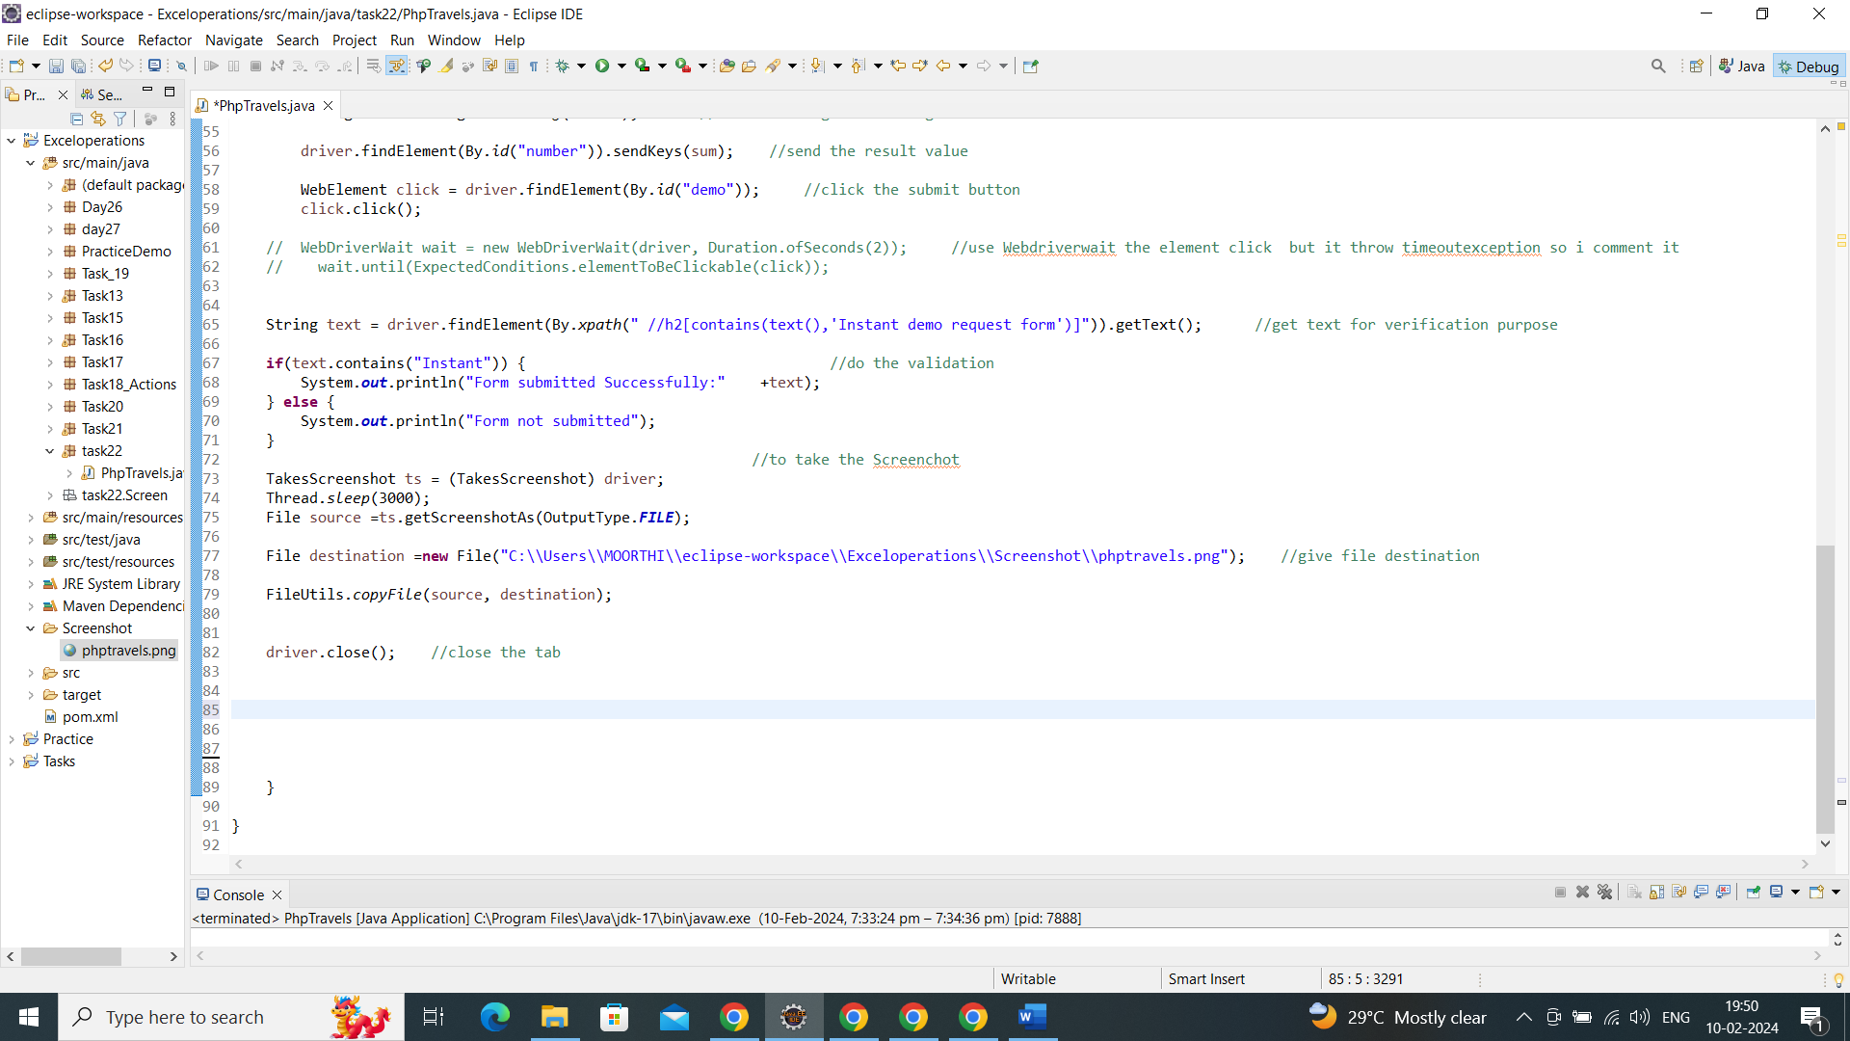

Console output:

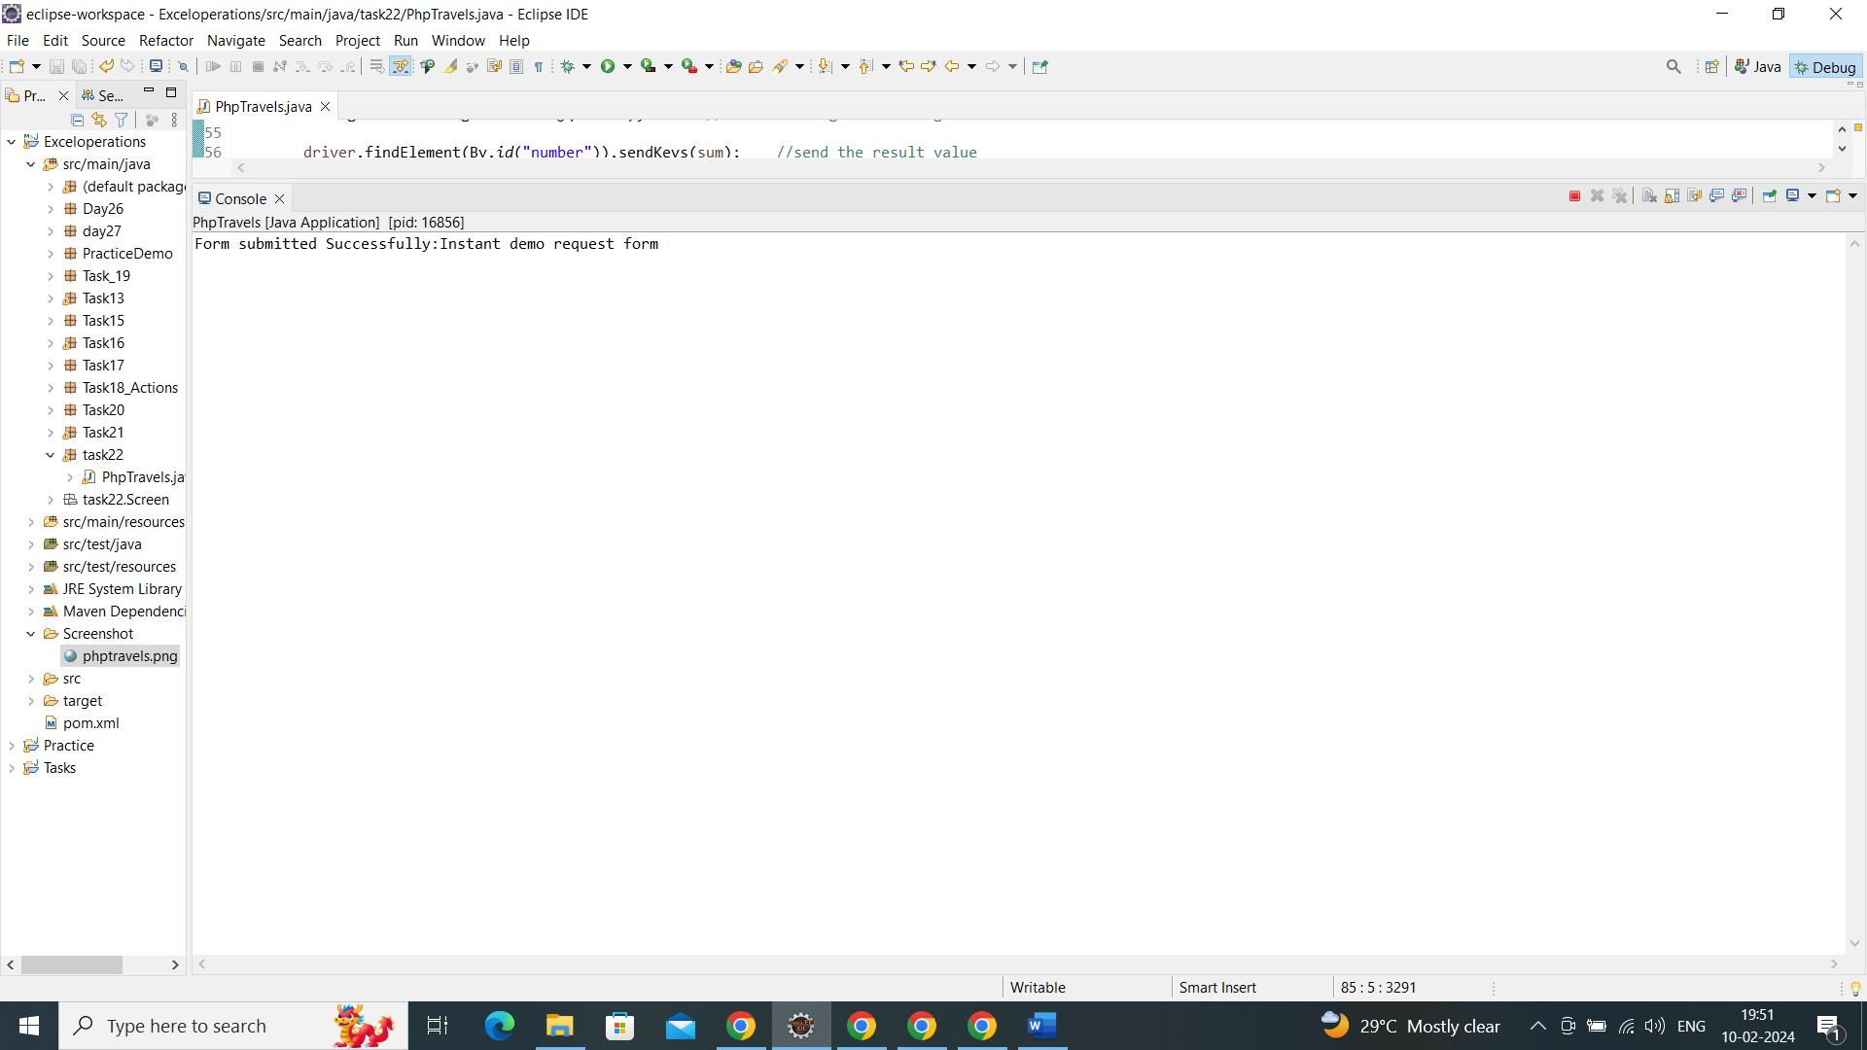

Output:

